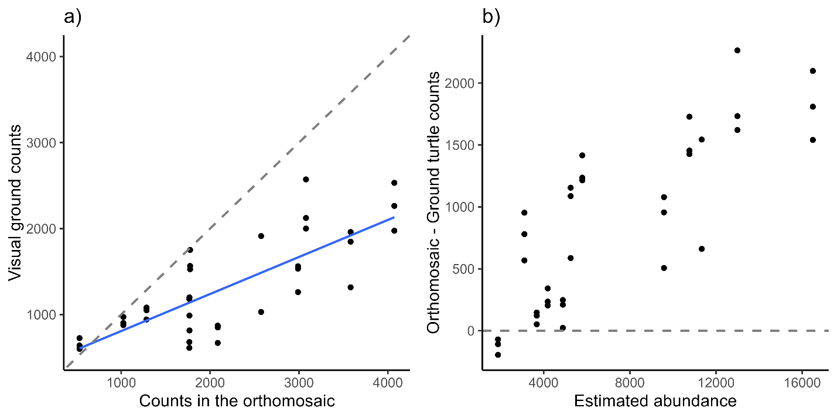

**Figure S1.** Comparison between the turtle counts in the drone-derived orthomosaic and visual ground counts. a) Relationship between the visual ground counts and the counts in the orthomosaic. Dashed line shows a 1:1 expected relationship, while the blue line indicates the actual predicted relation. b) Relationship between the difference between orthomosaic counts and visual ground counts and the daily abundance estimated from the developed model. Dashed line represents no difference between the methods across varying levels of abundance.

This figure illustrates that large numbers of turtles, particularly during the mass nesting events, hinder the effectiveness of visual ground counts for assessing abundance.